BPA241 Electronic Scales
The BPA241 series utilizes modern sensor technology and electronic technology.An electronic weighing device integrated with computer technology, meeting and address the practical requirements of "fast, accurate, continuous, and automated" weighing, while effectively eliminating human error Error, making it more in line with legal metrological management and industrial production Application requirements of process control.

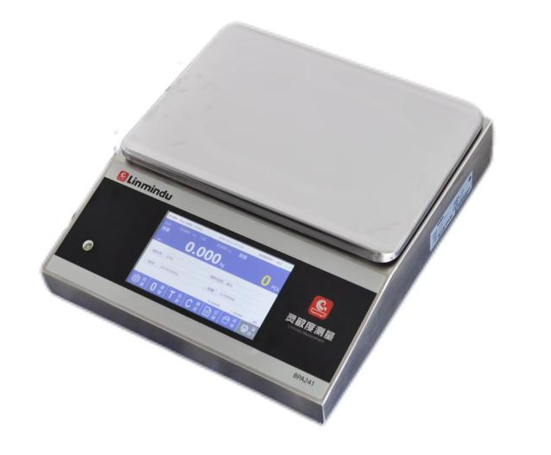

Product Features
- Human-computer interaction: Touch screen operation is simple and efficient even in the worst environment
- Label printing: Supports multiple label templates. You can freely set product label templates and the number of labels to print.
- Audit trail: All operations on the dashboard are logged, and the logs cannot be modified or deleted.
- User permissions: The instrument operator supports three-level permission management. Each operator can set their own permissions.
- Data storage: The device supports recording on internal storage or external storage (such as USB drives or SD cards).
- Communication protocols: The instrument supports multiple communication protocols, including HTTP, TCP/IP, and Modbus.
- Extended peripherals: Supports various peripherals such as label printers, barcode scanners, temperature and humidity sensors, card readers, and RFID devices.

Pecifications and mode

specifications | 3 kilograms | 6 kilograms | 15 kilograms | 30 kilograms
calibration division value | 1g | 2g | 5g | 10g
Display division value | 0.1g | 0.2g | 0.5g | 1g
/ | / | / | / | /

Application case
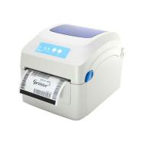
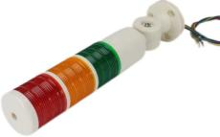
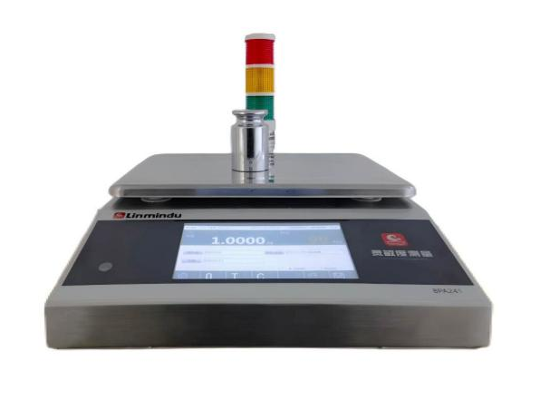

Connect the alarm light
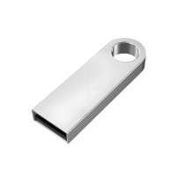
Connect Printer
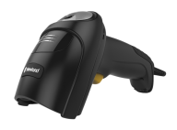

Connect the scanner
Export data to USB drive


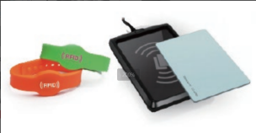

EPR,MES systems
Connect the card reader

Model | · | Option 1 | Option 2 | Source | Apply | System | Protection
0: No options
I: Passive 4 input
J: Active 4 input
O: Passive 4 outputs
P: Active 4 outputs
4: 4in4out
5: Active 4-in-4-out
W: Wifi module
B: Bluetooth module
G: 4G module
T: Humiture
A: 4~20mA module
V: 0~10V module
U: USB

N: Convention
H: IP67
K: IP69K
E: WinCe
L: Linux
W: Windows
A: Android

S: Standard Application
F: Standalone Manual Ingredient Mixing Application
E: Custom Non-Standard Application
0: Adapter
2: Adapter + Battery
3: AC + Battery

BPA241
0: No options
I: Passive 4 input
J: Active 4 input
O: Passive 4 outputs
P: Active 4 outputs
4: 4in4out
5: Active 4-in-4-out
W: Wifi module
B: Bluetooth module
G: 4G module
T: Humiture
A: 4~20mA module
V: 0~10V module
R: RS232
S: RS485
U: USB
0: No options
I: Passive 4 input
J: Active 4 input
O: Passive 4 outputs
P: Active 4 outputs
4: 4in4out
5: Active 4-in-4-out
W: Wifi module
B: Bluetooth module
G: 4G module
T: Humiture
A: 4~20mA module
V: 0~10V module
R: RS232
S: RS485
U: USB
0: No options
I: Passive 4 input
J: Active 4 input
O: Passive 4 outputs
P: Active 4 outputs
4: 4in4out
5: Active 4-in-4-out
W: Wifi module
B: Bluetooth module
G: 4G module
T: Humiture
A: 4~20mA module
V: 0~10V module
R: RS232
S: RS485
U: USB

Example: BPA241-000ELN

Changzhou Sensitivity Measurement Technology Co., Ltd.

Tel: 0519-88396070 13861012004
Email：changhua.zhao@lmdwt.com

Address: No.56 Fenglin Road, Zhonglou District, Changzhou City, Jiangsu Province
Website: www.lmdwt.com

